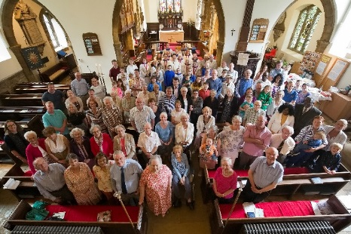
Abington Pastoral Letter No.27 28.08.2020

Dear Friends

Service on 30th August
If the weather forecast is going to be correct then we are still good to go with our open churchyard service on Sunday 30th of August.
I have attached the Order of Service to this email. However the service is designed to be a paperless service. You will be able to follow the service without the Order of Service in your hand. Of course, you can print it in your home and bring it with you if you wish.
If you would like to attend this service then it would be very helpful if you could give Dianne a ring (01604 281264) so we would know how many will be present at the service. If it rains on the day then there will be no service in the churchyard but we will livestream the service from inside the church building.
The service will continue to be held outside, weather permitting, throughout September. We are also hoping that we could have some music on Sunday 5th September. All services will be livestreamed on Youtube and Facebook. If you are not able to be physically present, you can still join our service online.

Church cleaning team: Help needed
When we start to have services in the church building their will need to be a team of people to clean the church before or after services depending where we are in the week. As you know, some of those who have been very generously helping us with this task are in high risk categories. The task is not huge but it cannot be left just to one or two each time. Your help will be very much appreciated. If you would like to help then please contact Donald at donaldloe@btinternet.com.

Prayer requests
Please continue to pray for Evelyn. Jackie has very kindly shared the update about her. She said.
She is still in the hospital. She has her good days and bad days but is making some progress and is very grateful for all the love and support she is receiving (please keep praying!) George has been to visit and say prayers with her which she finds very encouraging. Judith reads all the cards and newsletters to her. It is going to be a long process.
Please also continue to pray for Robert and Wendy. Robert was hospitalised again after feeling unwell. His condition is stable and is feeling comfortable at the moment. Sally, his niece, and Jane have been helping Wendy with packing as they are going to move to St. Christopher’s. Please pray for Robert that he will recover soon and for both of them as they prepare their move to St. Christopher’s.
We also remember Amelia and Grant at this time. This coming Sunday would have been their wedding day. It is now rescheduled on the 20th of March, 2020. Although their wedding plan had to be delayed, I know their love towards each other and their link with the church have been deepened even more in this global pandemic. God bless you Amelia and Grant. He will guide your path. We send our prayers and love to you both and to your respected families.
We give thanks to God as Malcolm and Jill approach together their wedding day. Their wedding will be on Wednesday 2nd of September at 2.30 pm at St. Alban’s Church. Revd. Judy, the vicar of St. Alban’s will conduct the service and I will be giving an address (short one!) at the service. This is a great joy not only to the couple and the family but also to the two churches, St. Alban and Ss. Peter and Paul, Abington as St. Alban’s started as the daughter church of Ss. Peter and Paul, Abington. The link between the two churches will be deepened and strengthened through this marriage and so will our mission for God’s Kingdom. Many congratulations Malcolm and Jill. May God pour out his abundant blessing upon you as you make one family in the presence of God.

I look forward to worshiping together with you all on Sunday wherever you are.

With love in Christ

Jun

