Creative Prayer – Trees
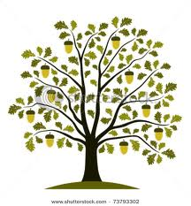

Jeremiah 17:7-8
⁷ Blessed are those who trust in the Lord,
whose trust is the Lord.
⁸ They shall be like a tree planted by water,
sending out its roots by the stream.
It shall not fear when heat comes,
and its leaves shall stay green;
in the year of drought it is not anxious,
and it does not cease to bear fruit.

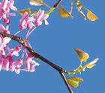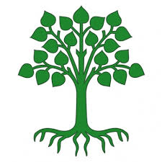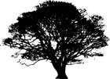

Reflection
Trees give us a wonderful model of contemplative prayer. It is about sending down our roots to the depths of the ground water of our being, in God. We, however, find it hard to trust this divine wisdom. We are programmed, from our earliest years, to ‘do’, to achieve, to succeed. Of course, the journey of faith also demands our effort, in living the gospel values in our daily lives. None of this will happen, though, if our roots are not immersed in the stream of God’s love and grace.
To be attentive to the still, small voice, we need to stay consciously connected to the source of our being, in stillness of heart and mind. If this is in place the rest will follow. If it is not, then there can be no leaves, no blossom, no enduring fruit on the tree we call our life.
God gives us his own model of ‘success’ and ‘achievement’ in something as simple and beautiful as a tree.
Look at a tree in the fullness of its blossom and you will see ‘success’. Pluck the cherries and you will understand ‘achievement’. All this happens because the trees send down their roots to the deep water.
In contemplative prayer we are doing nothing more than sending our roots deeper into the heart of God.
Activity
Go outside and find a tree to sit (or stand) with or find a photograph of a tree if you can’t go out. You will need to take some paper, a pencil, coloured pencils or felt tips or pastels.
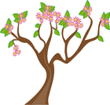
Draw an outline of your tree or any tree and put the answers to these questions on your drawing. Use words, pictures, shapes – whatever speaks to you.
What grounds you?
What fruit do you produce?
What feeds you?
What do you show to the world?
End by writing a prayer to thank God for his steadfastness. This might take the form of a poem or a psalm instead.
