Abington Worship Resources for Families and Children.
Contacts: Rev Jun Kim at prayandwork@gmail.com
Alison Canfield at alison.canfield@sky,com
Cathy Tinsley at cathytinsley18@gmail.com
July 2020 – Pack 8
We hope you are all keeping safe and well.
We will aim to provide family packs linked to a Bible story, with a prayer and some creative activities for families and children once a month while many of our children and young people remain off school.
Our focus for July is the story of The lost sheep. The Bible teaches us that we are like sheep and sometimes stray away from God. That makes God very sad, but he never gives up on us. He keeps searching for us and calling to us. He wants to draw us back into his arms. He even sent Jesus, his Son, to save those who are lost. Aren't you glad that God doesn't give up on his lost sheep? I am, because "I once was lost, but now I'm found.

Bible reference: Luke 15:3-7
The Story:
Then Jesus shared this parable: "Suppose one of you has a hundred sheep and loses one of them. Does he not leave the ninety-nine in the open country and go after the lost sheep until he finds it? And when he finds it, he joyfully puts it on his shoulders and goes home. Then he calls his friends and neighbours together and says, 'Rejoice with me; I have found my lost sheep.' I tell you that in the same way there will be more rejoicing in heaven over one sinner who repents than over ninety-nine righteous persons who do not need to repent.

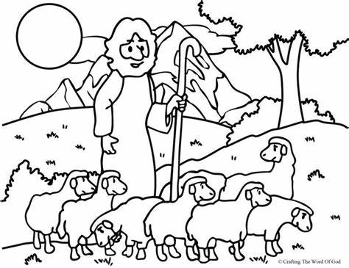
A wordsearch to try

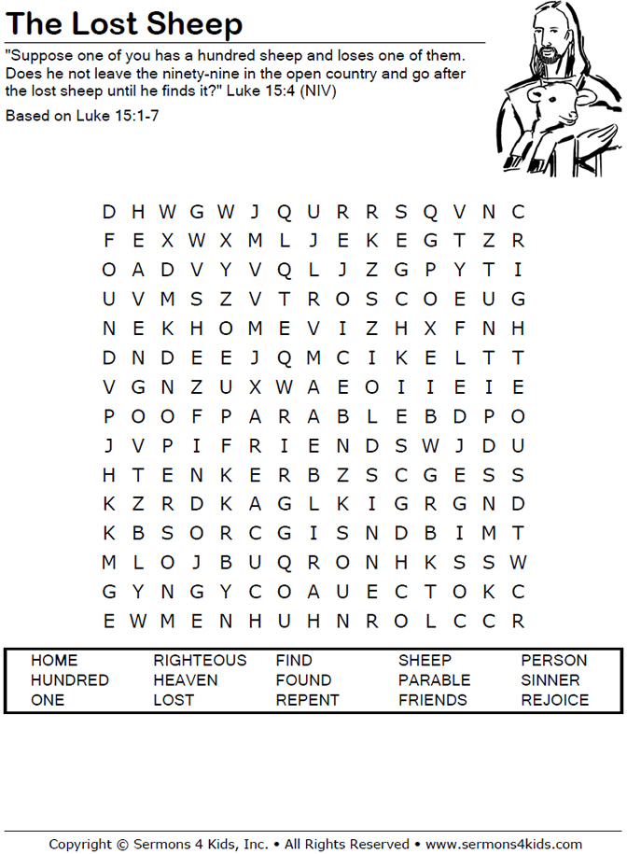

Some craft ideas:

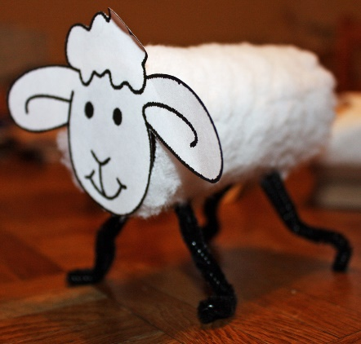

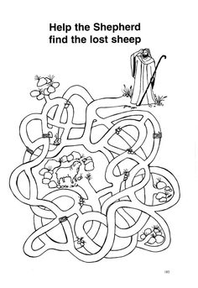
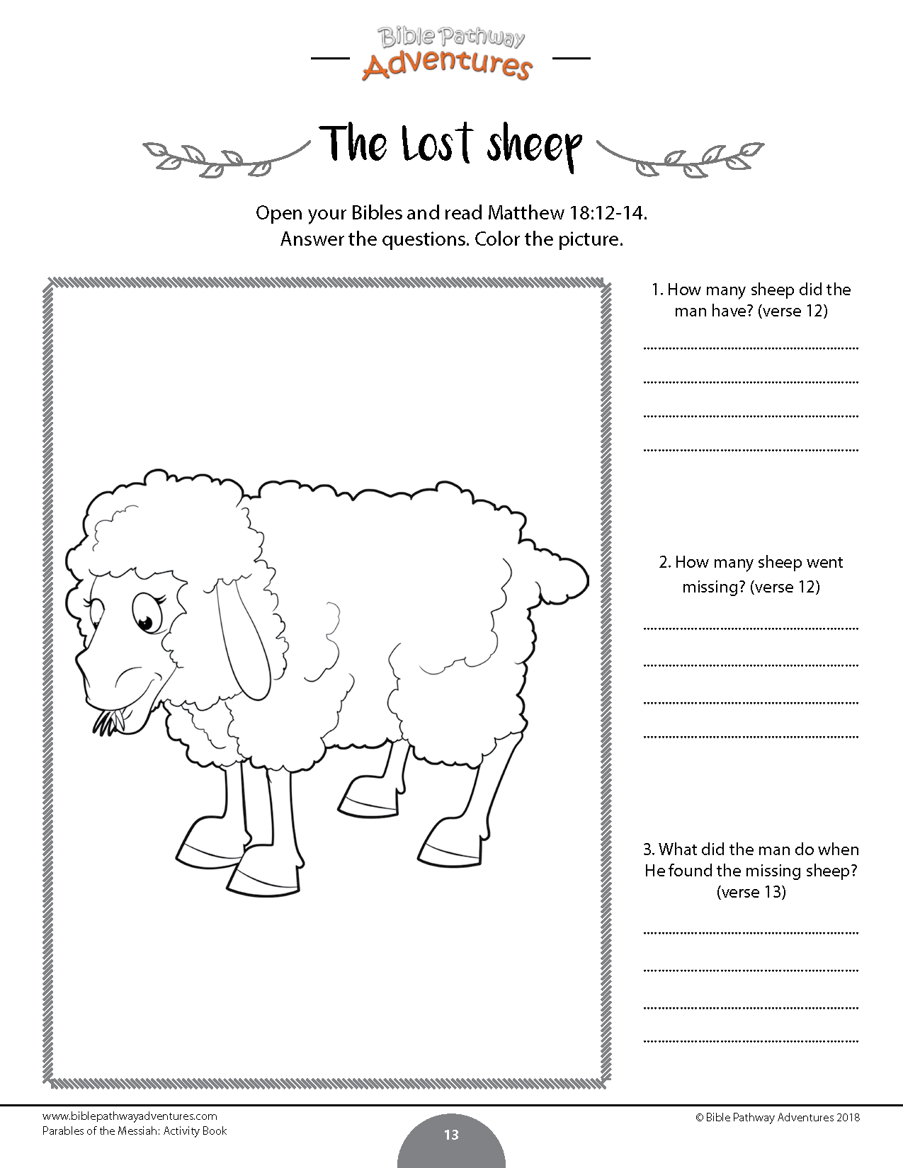

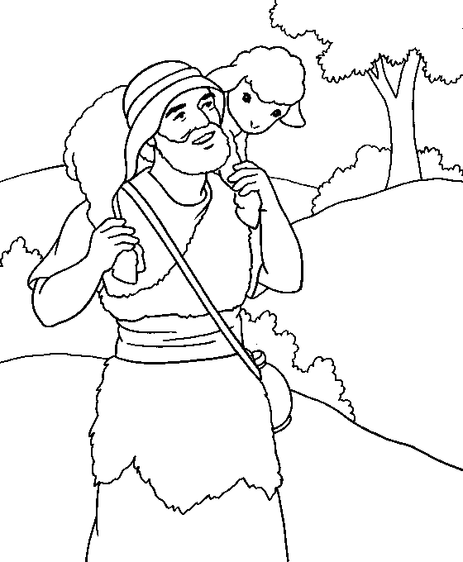

Family prayer

